**Question Bank on Unit-II**

1. Explain A* Algorithm . What do you mean by admissibility of A*.
2. Under what condition problem reduction algorithms are implemented
3. Explain AO* algorithm . Why there is need prorogate updated cost to all parents of a node.
4. How A* is different from AO*?
5. Explain minmax algorithm with example. What are its drawback
6. State the refinement of alpha beta cut off on minmax.
7. What are other additional refinement on minmax.
8. What are knowledge representation tools? Explain any two in detail
9. What are First Order Predicate logic (FOPL)? Convert following statement into FOPL
   * Marcus was man.
   * Marcus was Pompeian
   * All Pompeian's were Roman
   * Caesar was ruler
   * All Romans were either loyal to Caesar or hated him
   * Everyone is loyal to someone
   * People try to assassinate rulers they are not loyal to.
   * Marcus tried to assassinate Caesar
   * All men are people
10. What is resolution principle? Convert the following statement into FOPL, reduce them to clausal form. Prove by resolution that John like peanut
    * + - John likes all kinds of food.
        - Apple is a food.
        - Chicken is a food.
        - Anything anyone eats and is not killed by is food.
        - Bill eats peanuts and is still alive.
        - Sue eats everything Bill eats
11. What is backward chaining? Prove that John likes peanuts using backward chaining principle
12. What are sokelmization principle?Explain with example
13. What are steps to convert a statement into clausal form? Convert following statement into clausal form

“ *All Romans who know Marcus either hate Ceasar or think that anyone who hates anyone is crazy”*

1. How resolution principle can be used to obtain answer to a question?
2. What are semantic nets? Explain with example. Draw semantic net for following concept
   * Sarah fixed the chair with glew
   * John is taller than Bill
   * Birds are animal.Canary is bird and ostrich is also a bird. Canary can can sing and is yellow in color. All birds can fly. All animals has skin and can breathe. Ostrich cannot fly and is tall.
   * Every dog has bitten every mail carrier[*Hint: use partition Semantic network*]
3. What are frames? What are procedural and declarative frames?How inference is done

using frames? Explain with example.

1. What are scripts? How they are different from frames.Write a script for the following
   * Going to a restaurant
   * Going to a movie
2. What is shank theory of conceptual dependencies? State basic rules stated by under this theory.
3. Draw CD structure for the following
   * John pulled the cart
   * Boy ate icecream with spoon
   * I saw a fron in the woods
   * Bill Shot Bob
   * Rahut hit the ball with the bat
   * Bill gave book to Mary
4. Short notes on
   * Slot and filler structure
   * Unification algorithm
   * Skolemn constant anf function
   * Additional refinement

Problems on unit 2

* + 1. Steve like easy course. Scence courses are hard. All the courses of homescience department are easy. HS01 is a homescience course.

Prove Steve like HS01by resolution

1. ravelling sales person problem: A salesperson has to travel all the cities once and come back to the start city. If distance between the cities is given , find the minimum distance travelled by sales person using A* algorithm

2

5

14

13

15

14

12

9

11

10

21

20

22

3

1

4

21

20

22

3

1

4

2

5

14

13

15

14

12

9

11

10

1. Perform alpha beta cutting on the following tree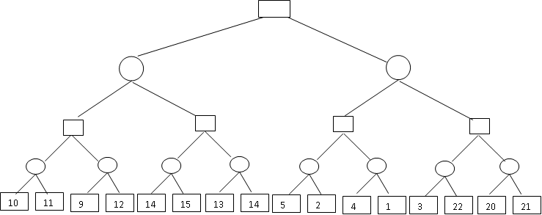



1. Given figure shows a partial AND-OR graph with static evaluation function (heuristics) at leaf nodes . Which is best path from root node A

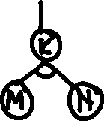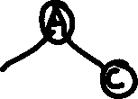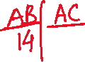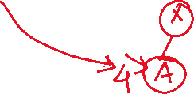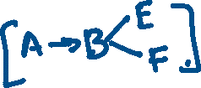

1. AO* may not find an optimal solution. Show with the help of an example.



1. Use AO* algorithm to transform the numeral 6 into strings of 1’s using the following rules. Assume that cost of connectors is k-unit and that value of static evaluation function at a node labelled by numeral 1 is zero and a node labelled by n is n. Draw AND-OR graph for the following rules:
   1. 6🡪5,1 6🡪4,2 5🡪4,1 5🡪3,2 4🡪3,1 4🡪2,2 3🡪2,1 2🡪1,1



* 1. 6🡪 3,3 6🡪4,3 4🡪2,2 4🡪3,1 3🡪2,1 2🡪2,1

1. Consider a state space where start state is numbered as 1 and the successor function for state numbered n returns two numbers 3n and 3n-1. Suppose goal state id 24. List the order in which the nodes will be visited using following searches



* 1. Depth first search
  2. Iterative deepening

